**Prelab for Lab4**

Xiaoyu Zhou, 1004081147

**Part I**

1. Draw a schematic of the gated D latch using interconnected 7400-series chips draw a schematic of the gated D latch using interconnected 7400-series chips.

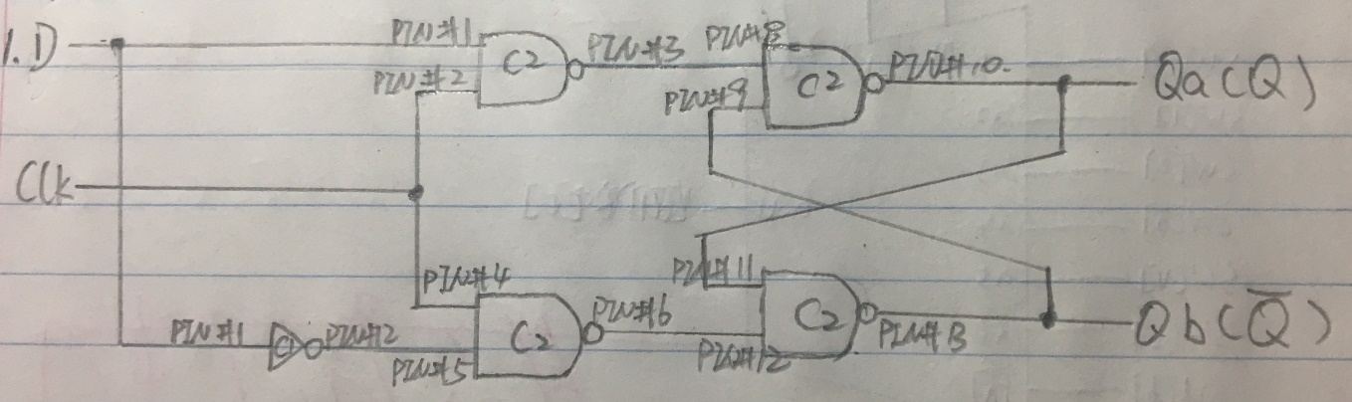

**CHIPS USED:**

C1 – 74LS04

C2 – 74LS00

**CONNCETED TO ALL CHIPS:**

PIN#7 – Gnd

PIN#14 – Vcc

4. Are there any input combinations of Clk and D that should NOT be the first you test?

No, we can use all the inputs since PIN#1 and PIN#5 will never be the same because they are D and D’. Thus, PIN#8 and PIN#12, which are the two inputs of the latch, will never be 0s at the same time. So, we don’t have to avoid any inputs.

**Part II**

1. Verilog.

module mux(LEDR, SW, KEY, HEX0, HEX1, HEX2, HEX3, HEX4, HEX5);

parameter Narrow = 4;

wire [Narrow-1:0] outt;

input [9:0] SW;

input [2:0] KEY;

output [9:0] LEDR;

output [6:0] HEX0;

output [6:0] HEX1;

output [6:0] HEX2;

output [6:0] HEX3;

output [6:0] HEX4;

output [6:0] HEX5;

trans u1(

.A(SW[3:0]),

.B(outt),

.in1(SW[7:5]),

.out1(LEDR[7:0])

);

D_flipflop a(

.d(LEDR[3:0]),

.clock(KEY[0]),

.reset_n(SW[9]),

.q(outt)

);

hex u2(

.in2(LEDR[3]),

.in3(LEDR[2]),

.in4(LEDR[1]),

.in5(LEDR[0]),

.o2(HEX4[0]),

.o3(HEX4[1]),

.o4(HEX4[2]),

.o5(HEX4[3]),

.o6(HEX4[4]),

.o7(HEX4[5]),

.o8(HEX4[6])

);

hex u3(

.in2(LEDR[7]),

.in3(LEDR[6]),

.in4(LEDR[5]),

.in5(LEDR[4]),

.o2(HEX5[0]),

.o3(HEX5[1]),

.o4(HEX5[2]),

.o5(HEX5[3]),

.o6(HEX5[4]),

.o7(HEX5[5]),

.o8(HEX5[6])

);

hex A(

.in2(SW[3]),

.in3(SW[2]),

.in4(SW[1]),

.in5(SW[0]),

.o2(HEX0[0]),

.o3(HEX0[1]),

.o4(HEX0[2]),

.o5(HEX0[3]),

.o6(HEX0[4]),

.o7(HEX0[5]),

.o8(HEX0[6])

);

assign HEX1[6] = 1;

assign HEX1[5] = 1;

assign HEX1[4] = 1;

assign HEX1[3] = 1;

assign HEX1[2] = 1;

assign HEX1[1] = 1;

assign HEX1[0] = 1;

assign HEX2[6] = 1;

assign HEX2[5] = 1;

assign HEX2[4] = 1;

assign HEX2[3] = 1;

assign HEX2[2] = 1;

assign HEX2[1] = 1;

assign HEX2[0] = 1;

assign HEX3[6] = 1;

assign HEX3[5] = 1;

assign HEX3[4] = 1;

assign HEX3[3] = 1;

assign HEX3[2] = 1;

assign HEX3[1] = 1;

assign HEX3[0] = 1;

endmodule

module D_flipflop(d, clock, reset_n, q);

parameter Narrow = 4;

parameter N = 1;

input [Narrow-1:0] d;

input [N-1:0] clock;

input [N-1:0] reset_n;

output [Narrow-1:0] q;

reg [Narrow-1:0] q;

always @(posedge clock)

begin

if (reset_n == 1'b0)

q <= 0;

else

q <= d;

end

endmodule

module trans(A, B, in1, out1);

parameter Width = 8;

parameter Narrow = 4;

parameter W = 3;

input [Narrow-1:0] A;

input [Narrow-1:0] B;

input [W-1:0] in1;

output [Width-1:0]out1;

reg [Width-1:0]out1;

wire c_out1, c_out2;

wire [Narrow-1:0] s_out1;

wire [Narrow-1:0] s_out2;

adder b1(

.a(A),

.b(B),

.c(1'b0),

.outc(c_out1),

.outs(s_out1)

);

adder b2(

.a(A),

.b(4'b0001),

.c(1'b0),

.outc(c_out2),

.outs(s_out2)

);

always @(*)

begin

case(in1)

3'b000: out1 = A * B;

3'b001: out1 = {A | B, A ^ B};

3'b010: out1 = {c_out1, s_out1};

3'b011: out1 = A + B;

3'b100: out1 = {c_out2, s_out2};

3'b101: out1 = |A | |B;

3'b110: out1 = B << A;

3'b111: out1 = B >> A;

default: out1 = 8'b0000_0000;

endcase

end

endmodule

module adder(a, b, c, outc, outs);

parameter Narrow = 4;

input [Narrow-1:0] a;

input [Narrow-1:0] b;

input c;

output outc;

output [Narrow-1:0] outs;

wire connect1, connect2, connect3;

full_adder e(

.A(a[0]),

.B(b[0]),

.cin(c),

.S(outs[0]),

.cout(connect1)

);

full_adder f(

.A(a[1]),

.B(b[1]),

.cin(connect1),

.S(outs[1]),

.cout(connect2)

);

full_adder g(

.A(a[2]),

.B(b[2]),

.cin(connect2),

.S(outs[2]),

.cout(connect3)

);

full_adder h(

.A(a[3]),

.B(b[3]),

.cin(connect3),

.S(outs[3]),

.cout(outc)

);

endmodule

module full_adder(A, B, cin, S, cout);

input A;

input B;

input cin;

output S;

output cout;

assign cout = A&B | A&cin | B&cin;

assign S = A ^ B ^ cin;

endmodule

module hex(in2, in3, in4, in5, o2, o3, o4, o5, o6, o7, o8);

input in2;

input in3;

input in4;

input in5;

output o2;

output o3;

output o4;

output o5;

output o6;

output o7;

output o8;

hex0 u1(

.c3(in2),

.c2(in3),

.c1(in4),

.c0(in5),

.out1(o2)

);

hex1 u2(

.c3(in2),

.c2(in3),

.c1(in4),

.c0(in5),

.out2(o3)

);

hex2 u3(

.c3(in2),

.c2(in3),

.c1(in4),

.c0(in5),

.out3(o4)

);

hex3 u4(

.c3(in2),

.c2(in3),

.c1(in4),

.c0(in5),

.out4(o5)

);

hex4 u5(

.c3(in2),

.c2(in3),

.c1(in4),

.c0(in5),

.out5(o6)

);

hex5 u6(

.c3(in2),

.c2(in3),

.c1(in4),

.c0(in5),

.out6(o7)

);

hex6 u7(

.c3(in2),

.c2(in3),

.c1(in4),

.c0(in5),

.out7(o8)

);

endmodule

module hex0(c3, c2, c1, c0, out1);

input c3; //selected when s is 0

input c2; //selected when s is 1

input c1; //select signal

input c0;

output out1; //output

assign out1 = ~c3 & c2 & ~c1 & ~c0 | c3 & c2 & ~c1 & c0 | c3 & ~c2 & c1 & c0 | ~c3 & ~c2 & ~c1 & c0;

endmodule

module hex1(c3, c2, c1, c0, out2);

input c3; //selected when s is 0

input c2; //selected when s is 1

input c1; //select signal

input c0;

output out2; //output

assign out2 = c2 & c1 & ~c0 | c3 & c1 & c0 | ~c3 & c2 & ~c1 & c0 | c3 & c2 & ~c0;

endmodule

module hex2(c3, c2, c1, c0, out3);

input c3; //selected when s is 0

input c2; //selected when s is 1

input c1; //select signal

input c0;

output out3; //output

assign out3 = ~c3 & ~c2 & c1 & ~c0 | c3 & c2 & c1 | c3 & c2 & ~c0;

endmodule

module hex3(c3, c2, c1, c0, out4);

input c3; //selected when s is 0

input c2; //selected when s is 1

input c1; //select signal

input c0;

output out4; //output

assign out4 = ~c3 & c2 & ~c1 & ~c0 | ~c2 & ~c1 & c0 | c2 & c1 & c0 | c3 & ~c2 & c1 & ~c0;

endmodule

module hex4(c3, c2, c1, c0, out5);

input c3; //selected when s is 0

input c2; //selected when s is 1

input c1; //select signal

input c0;

output out5; //output

assign out5 = ~c3 & c2 & ~c1 | ~c2 & ~c1 & c0 | ~c3 & c0;

endmodule

module hex5(c3, c2, c1, c0, out6);

input c3; //selected when s is 0

input c2; //selected when s is 1

input c1; //select signal

input c0;

output out6; //output

assign out6 = ~c3 & ~c2 & c0 | ~c3 & ~c2 & c1 | ~c3 & c1 & c0 | c3 & c2 & ~c1 & c0;

endmodule

module hex6(c3, c2, c1, c0, out7);

input c3; //selected when s is 0

input c2; //selected when s is 1

input c1; //select signal

input c0;

output out7; //output

assign out7 = ~c3 & ~c2 & ~c1 | c3 & c2 & ~c1 & ~c0 | ~c3 & c2 & c1 & c0;

endmodule

1. Simulation.

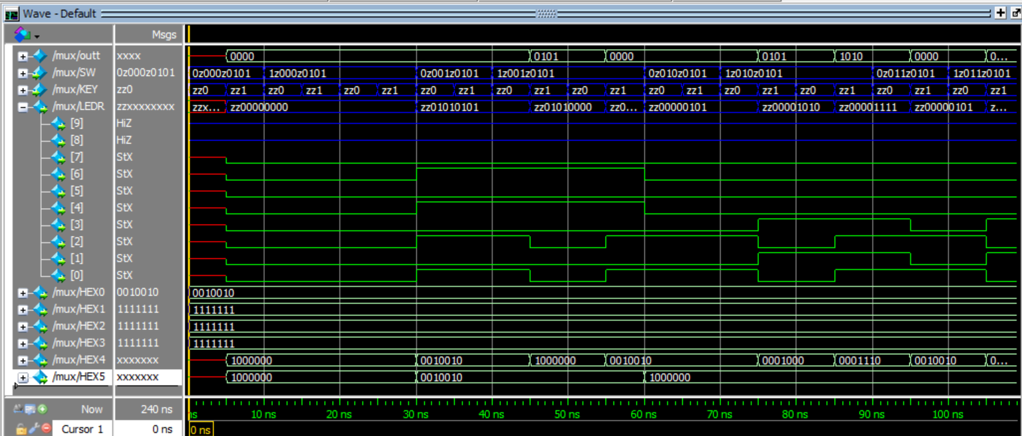

(this is just a part of all the simulation)

**Part III**

1. What is the behaviour of the 8-bit shift register shown in Figure 6 when *Load­­_n* = 1 and *ShiftRight* = 0?

The output of last time will be the new input, so there would be a recursion that the inout and the output will keep same until *Load­­_n* or *ShiftRight* change.

1. Draw a schematic.

Module ShifterBit

3.4. Write a Verilog.

module mux(LEDR, SW, KEY);

input [9:0] SW;

input [3:0] KEY;

output [9:0] LEDR;

wire getout1, getout2, getout3, getout4, getout5, getout6, getout7,getout8;

mux2to1 M1(

.x(1'b0),

.y(LEDR[7]),

.s(KEY[3]),

.m(getout1)

);

ShifterBit B1(

.load_val(SW[7]),

.in(getout1),

.shift(KEY[2]),

.load_n(KEY[1]),

.clk(KEY[0]),

.reset_n(SW[9]),

.out(getout2)

);

assign LEDR[7] = getout2;

ShifterBit B2(

.load_val(SW[6]),

.in(getout2),

.shift(KEY[2]),

.load_n(KEY[1]),

.clk(KEY[0]),

.reset_n(SW[9]),

.out(getout3)

);

assign LEDR[6] = getout3;

ShifterBit B3(

.load_val(SW[5]),

.in(getout3),

.shift(KEY[2]),

.load_n(KEY[1]),

.clk(KEY[0]),

.reset_n(SW[9]),

.out(getout4)

);

assign LEDR[5] = getout4;

ShifterBit B4(

.load_val(SW[4]),

.in(getout4),

.shift(KEY[2]),

.load_n(KEY[1]),

.clk(KEY[0]),

.reset_n(SW[9]),

.out(getout5)

);

assign LEDR[4] = getout5;

ShifterBit B5(

.load_val(SW[3]),

.in(getout5),

.shift(KEY[2]),

.load_n(KEY[1]),

.clk(KEY[0]),

.reset_n(SW[9]),

.out(getout6)

);

assign LEDR[3] = getout6;

ShifterBit B6(

.load_val(SW[2]),

.in(getout6),

.shift(KEY[2]),

.load_n(KEY[1]),

.clk(KEY[0]),

.reset_n(SW[9]),

.out(getout7)

);

assign LEDR[2] = getout7;

ShifterBit B7(

.load_val(SW[1]),

.in(getout7),

.shift(KEY[2]),

.load_n(KEY[1]),

.clk(KEY[0]),

.reset_n(SW[9]),

.out(getout8)

);

assign LEDR[1] = getout8;

ShifterBit B8(

.load_val(SW[0]),

.in(getout8),

.shift(KEY[2]),

.load_n(KEY[1]),

.clk(KEY[0]),

.reset_n(SW[9]),

.out(LEDR[0])

);

endmodule

module ShifterBit(load_val, in, shift, load_n, clk, reset_n, out);

input load_val, in, shift, load_n, clk, reset_n;

output out;

wire connect1, connect2;

mux2to1 M2(

.x(out),

.y(in),

.s(shift),

.m(connect1)

);

mux2to1 M3(

.x(load_val),

.y(connect1),

.s(load_n),

.m(connect2)

);

D_flipflop D1(

.d(connect2),

.clock(clk),

.reset_n(reset_n),

.q(out)

);

endmodule

module mux2to1(x, y, s, m);

input x; //selected when s is 0

input y; //selected when s is 1

input s; //select signal

output m; //output

assign m = s & y | ~s & x;

endmodule

module D_flipflop(d, clock, reset_n, q);

parameter N = 1;

input [N-1:0] d;

input [N-1:0] clock;

input [N-1:0] reset_n;

output [N-1:0] q;

reg [N-1:0] q;

always @(posedge clock)

begin

if (reset_n == 1'b0)

q <= 0;

else

q <= d;

end

endmodule

5. Simulation.

